St. Joseph’s Catholic Church Oatley
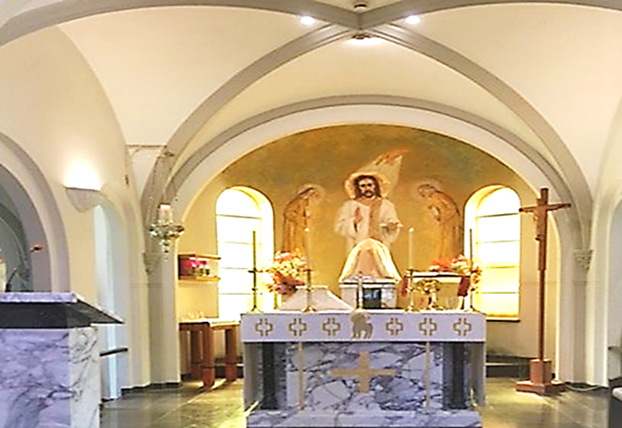
PO Box 105 (21C Frederick Street) Oatley 2223
Rev. Paul Hilder – Parish Priest
Mrs. Nancy Miletic – Operations Manager (Tues & Wed)
‘Phone 9580 1864, Email: oatleycc@bigpond.net.au
Parish website: www.stjosephschurch.com.au
St. Joseph’s Catholic Primary School, Oatley
Mrs Kylie Brakel – Principal. ‘Phone 9580 6588

St. Joseph’s Mass Times
Saturday Vigil: 5.00 pm Sunday: 8 am and 10 am
Weekday Masses: at 8 am on Monday, Tuesday, Wednesday, Friday & Saturday
Thursday: Mass at 12 md
Public Holidays: 9 am only
Confessions are available before the 5 pm Vigil Mass (4 pm to 4.45 pm)

WELCOME BACK
St Joseph’s Church is open from 7 am to 6 pm daily, and the usual Mass timetable as above apply. We look forward to seeing everyone at Mass.

10th July 2022 – Fifteenth Sunday in Ordinary Time

Masses for the Deceased: Father Kevin O’Grady, Omas Brischetto, Bruna Pollachini, recently deceased; Jessie Murphy, Mara Beljo, Imelda Saunders, Kathleen O’Brien, Matthew Sinclair, Freda Jenner, Terrence McKeon, Fr. Basil Jansen, Peter Convento, anniversary: Deceased members of the Milan family, Sadie and Samuel Mir, George and Therese Mir, Norman Mir and deceased members of the Mir family anniversaries.

WHO IS MY NEIGHBOUR? A book was written by a man who related in it a terrible experience that he had at Waterloo Station in London. While drinking a cup of tea alone he went suddenly blind in a matter of seconds. When it happened, he reached out in his terrible fear to a man standing next to him, explained what had happened and asked him to fetch help. The man said he would and left. He did not come back. After a time, the blind man clutched at someone else and went through the same explanation, with a like promise and a like result. In all he asked seven people to help him, all seven said they would, and went away, leaving him alone. The eighth man said he would get help and did. When the blind man tried to thank him, he would have none of it. “Good heavens”, he said, “that’s nothing. Anyone would have done the same.”
We all know the answer to the question arising from that story “Who was the neighbour to the blind man?” “Who acted the part of the Good Samaritan?” It is clear from Our Lord’s parable that our neighbour is not just the person who lives in our neighbourhood. Everyone, even the perfect stranger, is our neighbour in Our Lord’s use of the word. Why is this so? Simply because all people are united together in one big family both by the creative power of God and the blood of Christ. They are all therefore the objects of God’s love and what God loves we must love also. God willed that the incarnation should become, in some real sense, a re-incarnation in everyone so that all should live by the life of Christ. Fundamentally, therefore, the reason why we should look on all people as our neighbour is because Our Lord wishes to identify himself with us. It is Christ who lives in the poor, the wretched, the hungry, the lonely and the homeless. And it is our duty, as far as we are able, to act the Good Samaritan towards them. Just as Our Lord healed our wounds by dying for us, so should we heal his wounds in others.
CONFIRMATION: The children of the parish who are eligible to receive the Sacrament of Confirmation this year, have completed their classes and preparation to receive the Sacrament at St. Mary’s Cathedral on Sunday, 7th August. Please keep them in your prayers and encourage them to faithfully practice their faith.
REMINDER for applications for the combined Reconciliation 2021 Catchup and First Holy Communion 2022 program will close on 10 July 2022 (open to any child in year 3 or above). Applications for children who will only be receiving FHC this year close on 7 August 2022. For further details and application forms refer to below.
RECONCILIATION 2021 CATHCUP (Year 3 and above) Term Three: Applications are now open – Close 10th July. (See details on the parish website www.stjosephschurch.com.au in the tab Sacramental Dates 2022). Additionally, click on the application form attached for further details and enrolment. Application and enrolment.

​FIRST HOLY COMMUNION 2022 (Year 3 and above) Term Three: Applications now open – Close 7th August. (See details on the parish website www.stjosephschurch.com.au in the tab Sacramental Dates 2022). Additionally, click on the application form attached for further details and enrolment. Application and enrolment.

RECONCILIATION 2022 (Year 2 and above) Term Four: Applications open at the end of Term 3. (See details on the parish website www.stjosephschurch.com.au)

SAVE THE DATE -NEXT PARISH MORNING TEA: Friday 22 July at 10.30am. Thank you to everyone who participated and volunteered at the previous Parish morning teas. Due to the great turnout and enjoyable get togethers at the morning tea, we will be holding another one on Friday 22 July at 10.30am in the Marion Hall (go through the Church). Everyone is WELCOME. Please join us. Fr. Paul
Church Open: Our church is open each day for weekday Masses and Sunday Masses at 5pm (Saturday Vigil), 8am and 10am, Sundays. We look forward to seeing everyone at Mass.

The Parish now has the facility to stream our Sunday Masses: You can access this on YouTube by following this link: bit.ly/stjoatley OR
CURRENT PLANNED GIVING: Planned Giving Envelopes for the new financial year are now available in the foyer of the Church, please take your set of envelopes.

New Contributors: If you wish to become part of our regularly giving programme at St Joseph’s Parish Oatley, please fill in the planned giving form, which can be accessed by clicking on the following Application Form. You can choose between making a regular monthly credit card contribution. Whereby, once set up, your contribution is processed each month. This is a good way to "set and forget" you’re giving to support the running of our parish. Alternatively, you may wish to contribute via the envelope system. If you would like to give by credit card on a monthly basis, OR give via the envelope system please download and complete the attached Application Form

Alternatively, please pick up a form in the Church foyer or email the office for a copy. Upon completion of your details email it to oatleycc@bigpond.net.au otherwise place the form in the second collection.

Your contribution to the 2nd collection goes towards the running and upkeep of our parish, and 30% of what you donate is eligible for a tax deduction.

TAX RECEIPTS for 2021-2022 will be available in the middle of August. Please email oatleycc@bigpond.com if you wish to receive a tax receipt. Your receipts will be emailed to you. Alternatively, call the office on 9580-1864 for your tax receipt. Once again, we would like to thank all who have kindly contributed to our parish at St Joseph’s Oatley.

Thank you for contributing to St. Joseph’s Parish. Fr. Paul

