St. Joseph’s Catholic Church Oatley

PO Box 105 (21C Frederick Street) Oatley 2223

Rev. Paul Hilder – Parish Priest

Mrs. Nancy Miletic – Operations Manager (Tues & Wed)

‘Phone 9580 1864, Email: [oatleycc@bigpond.net.au](mailto:oatleycc@bigpond.net.au)

Parish website: [www.stjosephschurch.com.au](http://www.stjosephschurch.com.au)

St. Joseph’s Catholic Primary School, Oatley

Mrs Kylie Brakel – Principal. ‘Phone 9580 6588

St. Joseph’s Mass Times

**Saturday Vigil**: 5.00 pm **Sunday:** 8 am and 10 am

**Weekday Masses**: at 8 am on Monday, Tuesday, Wednesday, Friday & Saturday

**Thursday:** Exposition of the Blessed Sacrament and Benediction from 11 am and

Mass at 12 md

**Public Holidays:** 9 am only

Confession are available before the 5 pm Vigil Mass (4 pm to 4.45 pm)

16th May 2021 – The Ascension of the Lord.

THE ASCENSION OF THE LORD: There are two important results that followed from Christ’s Ascension into Heaven. The first is that he made himself available to all. He did not depart into some distant habitation where he would have been inaccessible. His visible presence on earth was ended but always he would be invisibly present to all who wished to be in contact with him.

The second important result was that in future faith would be required to recognise his presence. His words that *blessed are they who have not seen but believed* would come true. Christ left the world and yet he remained. His power was not to be confined to Palestine but would be universally exercised. *I will be with you all days even to the end of the world,* he said. To do this he went back to the Father so that he could reign over the hearts of all. Now he could say, in the words of the book of Revelation, *he who conquers, I will grant him to sit with me on my throne, as I myself conquered and sat down with my Father on his throne.* Christ, in other words, went back to his Father in Heaven so that we might one day have a Heaven to go to. *In my Father’s house there are many rooms,* he said, *if it were not so would I have told you that I go to prepare a place for you?*

The glory of which Christ emptied himself when he came down on earth was completely restored to him at the Ascension and it is a glory in which we can all share as he himself said, when he prayed to his Father *the glory you have given to me I have given to them.* This final departure of Christ from his visible work in Palestine was very much to our advantage. It was a guarantee to us that Christ at the end of his life did not lay aside his humanity. He will always share that humanity with us and so love us both with a human and divine love.

**Masses for the Deceased:** Brian Rayment, Kerry Ryan, Shirley Clare,Father Michael McCarthy (former Parish Priest of Oatley), Cardinal Edward Edris Cassidy, recently deceased, Lucy McCallum, Frances Canham, Helen Wright, anniversaries, Lucia and Giovanni Tesoriero, Rosena and Salvatore Trimboli, Christopher Trimboli, Cecilia Kramar.

**Fr. Paul’s Holidays:** I will be on annual leave from the 18th to the 28th of May. During that time there will be no weekday Masses in the parish until Tuesday, 1st June. I will return for the Weekend Masses on 29th/30th May. During my absence, Father Peter Gardner CP (an old boy of the parish) will attend to the Masses on the weekend 22nd and 23rd May (Pentecost).

**The Parish now has the facility to stream our Sunday Masses:** You can access this on YouTube by following this link:

[bit.ly/stjoatley](http://bit.ly/stjoatley) or

.



**You can also access it by going to the Archdiocese of Sydney website where there is a list of Churches who stream their Masses each week. Just click on the link for St. Joseph’s Parish, Oatley.**

**Sacramental Program for 2021:** Please visit the Parish website: [www.stjosephschurch.com.au](http://www.stjosephschurch.com.au)

**Imposition of restrictions concerning Churches**: From Friday, 12th February, an unlimited number of people can attend Mass, provided that the one person per 2 metre square rule is observed. However, our Church will only hold at least eighty according to this regulation, any overflow would have to be accommodated in the Marion Hall where the Mass can be viewed on the TV monitor. Because of the easing of the restrictions, the Archbishop has lifted the dispensation from our Sunday Mass obligation. ***Parishioners are once again obliged******to attend Mass on Sundays and Holy Days of obligation when this is reasonably*** ***possible.*** Those of great age, have health conditions or are otherwise anxious about the risks of Covid19 are free to remain at home and find another way of keeping the Sabbath holy. There is still the requirement of taking names and contact details of attendees. The use of a QR code is recommended for those with iPhones or smart phones. The NSW Services app would need to be install on your phone to access the code. The first time you use the code, it will ask you to provide your name and contact number. It will then send you a code to enter with your details and the app will then be active. It is then used every time you attend Mass, or when and where you visit other venues that have a QR code registration system in place.

The wearing of masks is no longer mandatory, but strongly recommended where social distancing is not possible.

Parishioners who elect to attend Mass during the pandemic should consider the safety of other parishioners by staying away if they are unwell, and if so, getting tested and self-isolating while awaiting the results. It is also advisable that parishioners only attend Mass in their own parish and not move from parish to parish.

The need is acute!

Low-income communities are not asking us for money or gifts. They reject degrading dependence. They want you to share your skills to help develop self-reliance and sustainable solutions to poverty. The call is to all trades and professions to assist build the ability of their people and the capacity of their organisations. To properly prepare for a 2022 placement you do need to [enquire now](https://palms.org.au/assignments-abroad/).

**Visit** [**palms.org.au**](http://www.palms.org.au/) **, call Palms on 02 9560 5333 or email** [**palms@palms.org.au**](mailto:palms@palms.org.au)

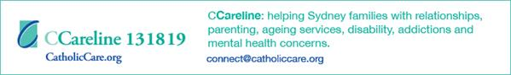

**PLANNED GIVING: Your contribution to the 2nd collection goes towards the running and upkeep of our parish, and 30% of what you donate is eligible for a tax deduction.**

**TAX RECEIPTS for 2019-2020** are now available, if you wish to receive a tax receipt please email: [oatleycc@bigpond.net.au](mailto:oatleycc@bigpond.net.au)

**New Contributors**: Please refer to the planned giving form, which can be accessed on the website under **DONATIONS,** if you wish to become part of our regularly giving programme at St Joseph’s Parish Oatley. Upon completion of the form please email to [oatleycc@bigpond net.au](mailto:oatleycc@bigpondnet.au)

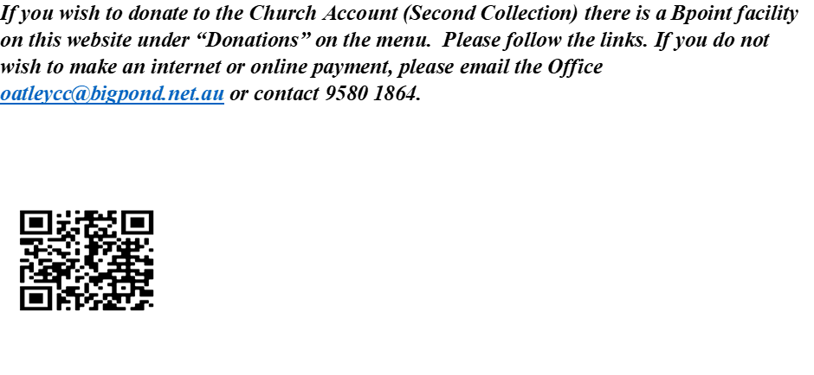

***Thank you for your contributing to St. Joseph’s Parish. I am very appreciative of your ongoing generosity and commitment to support our Parish in achieving its Pastoral Mission and meeting ongoing expenses. Fr. Paul.***

**16th May 2021 – The Ascension of the Lord.**

**THE INTRODUCTORY RITES**

**Entrance Procession**

***Men of Galilee, why gaze in wonder at the heavens?***

***This Jesus whom you saw ascending into heaven***

***will return as you saw him go, alleluia.***

**Penitential Act**

I confess to almighty God

and to you, my brothers and sisters,

that I have greatly sinned,

in my thoughts and in my words,

in what I have done and in what I have failed to do,

through my fault, through my fault,

through my most grievous fault;

therefore I ask blessed Mary ever-Virgin,

all the Angels and Saints,

and you, my brothers and sisters,

to pray for me to the Lord our God.

May almighty God have mercy on us, forgive us our sins,

and bring us to everlasting life.

Amen.

Lord, have mercy.  **Lord, have mercy.**

Christ, have mercy. **Christ, have mercy.**

Lord, have mercy. **Lord, have mercy.**

**Gloria**

Glory to God in the highest,

and on earth peace to people of good will.

We praise you,

we bless you,

we adore you,

we glorify you,

we give you thanks for your great glory,

Lord God, heavenly King,

O God, almighty Father.

Lord Jesus Christ, Only Begotten Son,

Lord God, Lamb of God, Son of the Father,

you take away the sins of the world,

have mercy on us;

you take away the sins of the world,

receive our prayer;

you are seated at the right hand of the Father,

have mercy on us.

For you alone are the Holy One,

you alone are the Lord,

you alone are the Most High,

Jesus Christ,

with the Holy Spirit,

in the glory of God the Father.

Amen.

**Collect**

Let us pray.

Gladden us with holy joys, almighty God,

and make us rejoice with devout thanksgiving,

for the Ascension of Christ your Son

is our exaltation,

and, where the Head has gone before in glory,

the Body is called to follow in hope.

Through our Lord Jesus Christ, your Son,

who lives and reigns with you in the unity of the Holy Spirit,

God, for ever and ever.

Amen.

**THE LITURGY OF THE WORD** (Refer to your Sunday Missal or Liturgy Sheet)

**PROFESSION OF FAITH (Nicene Creed)**

I believe in one God,

the Father almighty,

maker of heaven and earth,

of all things visible and invisible. I believe in one Lord Jesus Christ,

the Only Begotten Son of God,

born of the Father before all ages.

God from God, Light from Light,

true God from true God,

begotten, not made, consubstantial with the Father;

through him all things were made.

For us men and for our salvation

he came down from heaven,

At the words that follow, up to and including 'and became man', all bow.

and by the Holy Spirit was incarnate of the Virgin Mary,

and became man. For our sake he was crucified under Pontius Pilate,

he suffered death and was buried,

and rose again on the third day

in accordance with the Scriptures.

He ascended into heaven

and is seated at the right hand of the Father.

He will come again in glory

to judge the living and the dead

and his kingdom will have no end.

I believe in the Holy Spirit, the Lord, the giver of life,

who proceeds from the Father and the Son,

who with the Father and the Son is adored and glorified,

who has spoken through the prophets.

I believe in one, holy, catholic and apostolic Church.

I confess one Baptism for the forgiveness of sins

and I look forward to the resurrection of the dead

and the life of the world to come. Amen.

**UNIVERSAL PRAYER FOR THE ASCENSION OF THE LORD**

**PRIEST: *My dear brothers and sisters in Christ, let us offer our petitions through the Lord Jesus, who was taken up to heaven and intercedes for us at the right hand of the Father.***

1. For all who share one Lord, one faith, one baptism. Adorned with a rich variety of gifts, may the Church bear witness to the ends of the earth. *Let us pray to the Lord.*
2. For all races and nations. May the children of the one God and Father of all, make every effort to maintain the unity of the Spirit in the bond of peace. *Let us pray to the Lord.*
3. For prisoners of conscience and those held captive. By the gift of grace, may they persevere in humility and patience. *Let us pray to the Lord.*
4. For the apostles, prophets, evangelists, pastors and teachers in this community and throughout the Church. May their work of ministry build up the body of Christ in unity of faith. *Let us pray to the Lord.*
5. For those who consecrate their work, professions and business to Christ. May they receive the strength to fulfill their duties in a Christian manner. *Let us pray to the Lord.*
6. For those taken from our sight by death. May they be with Christ in glory at the right hand of God. *Let us pray to the Lord.*
7. May the intercession of the Blessed Virgin Mary, Help of Christians and Patroness of Australia, guard and prosper the faith in our country, and make us worthy of promises of Christ. **HAIL MARY.**

**PRIEST: *Father, you glorified your Son, and in him we will be glorified. Welcome our prayers because we belong to you. We ask this through Christ our Lord. AMEN.***

**Pope Francis Prayer for protection from Coronavirus**

O Mary, you shine continuously on our journey as a sign of salvation and hope. We entrust ourselves to you. Health of the sick. At the foot of the Cross you participated in Jesus’ pain, with steadfast faith. You, our Salvation, know what we need. We are certain that you will provide, so that, as you did at Cana of Galilee, joy and feasting might return after this moment of trial. Help us, Mother of Divine Love, to conform ourselves to the Father’s will and to do what Jesus tells us: He who took our sufferings upon Himself, and bore our sorrows to bring us, through the Cross, to the Joy of the Resurrection. Amen.

We seek refuge under your protection, O Holy Mother of God. Do not despise our pleas – we who are put to the test – and deliver us from every danger, O glorious and blessed Virgin.

**Our Spiritual Communion**

***My Jesus, I believe that you are present in the most Blessed Sacrament. I love You above all things and I desire to receive You into my soul. Since I cannot now receive you sacramentally, come at least spiritually into my heart. I embrace You as if You have already come and unite myself wholly to You. Never permit me to be separated from You. Amen.***

Our Father, Hail Mary, Glory be *etc.*

**Communion Antiphon**

***Behold, I am with you always,***

***even to the end of the age, alleluia.***

**Prayer after Communion**

Let us pray.

Almighty ever-living God,

who allow those on earth to celebrate divine mysteries,

grant, we pray,

that Christian hope may draw us onward

to where our nature is united with you.

Through Christ our Lord.

Amen.

**BLESSING**

May God, who by the Resurrection of his Only Begotten Son

was pleased to confer on us

the gift of redemption and of adoption,

give us gladness by his blessing.

Amen.

May he, by whose redeeming work

We have received the gift of everlasting freedom,

make us heirs to an eternal inheritance.

Amen.

And may we, who have already risen with Christ

in Baptism through faith,

by living in a right manner on this earth,

be united with him in the homeland of heaven.

Amen.

And may Almighty God bless us all, in the name of the Father, and of Son and of the Holy Spirit. Amen.

***Let us praise the Lord and glorify him in our lives.*** Thanks be to God.

***If you wish to donate to the Church Account (Second Collection) there is a Bpoint facility on this website under “Donations” on the menu. Please follow the links. If you do not wish to make an internet or online payment, please email the Office*** [***oatleycc@bigpond.net.au***](mailto:oatleycc@bigpond.net.au) ***or contact 9580 1864.***

