St. Joseph’s Catholic Church Oatley
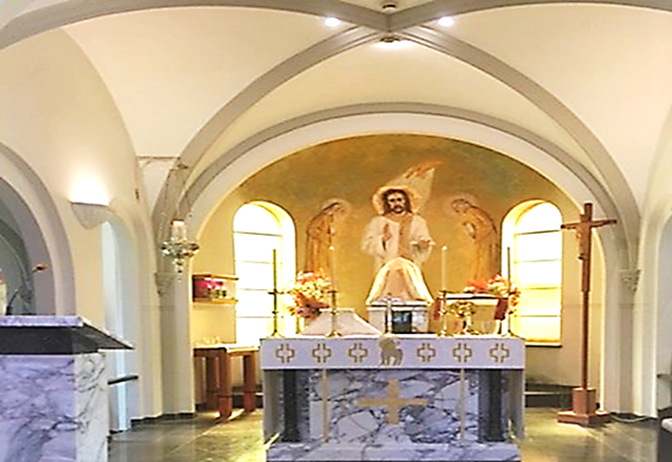
PO Box 105 (21C Frederick Street) Oatley 2223
Rev. Paul Hilder – Parish Priest
Mrs. Nancy Miletic – Operations Manager (Tues & Wed)
‘Phone 9580 1864, Email: oatleycc@bigpond.net.au
Parish website: www.stjosephschurch.com.au
St. Joseph’s Catholic Primary School, Oatley
Mrs Kylie Brakel – Principal. ‘Phone 9580 6588

St. Joseph’s Mass Times
Saturday Vigil: 5.00 pm Sunday: 8 am and 10 am
Weekday Masses: at 8 am on Monday, Tuesday, Wednesday, Friday & Saturday
Thursday: Mass at 12 md
Public Holidays: 9 am only
Confessions are available before the 5 pm Vigil Mass (4 pm to 4.45 pm)

WELCOME BACK
St Joseph’s Church is open from 7 am to 6 pm daily, and the usual Mass timetable as above apply. We look forward to seeing everyone at Mass.

24th July 2022 – Seventeenth Sunday in Ordinary Time

Masses for the Deceased: Masses for the Deceased: Father Kevin O’Grady, recently deceased; Ellen Mavis Hilder, Michelle Rooney, Laurence Battikha, Ellen and John Perkins, anniversaries.

PERSEVERING PRAYER: It is easy to be rather casual about prayer and to expect great results without much effort. Our Lord is telling us in today’s Gospel that we must persevere in prayer. We must go on knocking if we want the door to be opened. In other words, we must not only put our heart and soul into what we ask for but must go on asking continually. This is what St. Augustine’s mother, St. Monica, did. “It is impossible that the son of these tears should perish,” he said. His mother had prayed long and hard for him with splendid results for the world.
Christ tells us that if we ask with persistence we will receive. But this does not seem to happen always. The answer is that every good prayer is answered but not always in the way we would like it to be. Every prayer should have the proviso: Not my will but thine be done. That, after all, was the way Our Lord prayed in the garden of Gethsemane. This implies that when we pray, we must have a profound faith. This does not mean that we are to have a certainty about the outcome of our prayer, that we will get what we asked for. It means that we have a complete faith in the God we pray to; faith that our prayer will be answered in the way God sees fit. It will always be a good way as Christ tells us: What father among you, if his son asks for a fish, will instead of a fish, give him a serpent? If we ask with fervour for something we may be sure that God will not give us what is not good for us. Whatever he does give will be for our spiritual good. The person who prayed to God for neither riches nor poverty but simply three thousand pounds a year paid quarterly in advance was not likely to obtain it because there was too much of self in the prayer. Our Prayer must go away from self and be directed towards God. Someone has said that the one who prays rises from their knees a better person.
Church Open: Our church is open each day for weekday Masses and Sunday Masses at 5pm (Saturday Vigil), 8am and 10am, Sundays. We look forward to seeing everyone at Mass.
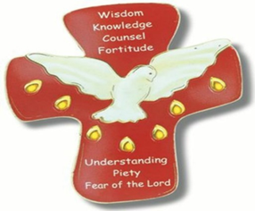
CONFIRMATION: The children of the parish who are eligible to receive the Sacrament of Confirmation this year, have completed their classes and preparation to receive the Sacrament at St. Mary’s Cathedral on Sunday, 7th August. Please keep them in your prayers and encourage them to faithfully practice their faith.

​
FIRST HOLY COMMUNION 2022 (Year 3 and above) Term Three: Applications now open – Close 7th of August. (See details on the parish website www.stjosephschurch.com.au in the tab Sacramental Dates 2022). Additionally, click on the application form attached for further details and enrolment. Application and enrolment.

RECONCILIATION 2022 (Year 2 and above) Term Four: Applications open at the end of Term 3. (See details on the parish website www.stjosephschurch.com.au)
CHILDREN’S LITURGY during the Sunday 10am Mass
We are looking forward to welcoming our young parishioners back to Children’s Liturgy during the 10am Sunday Mass. Children will have the opportunity to celebrate and reflect on the Sunday Gospel reading in an age-appropriate way. Children are led through prayer, songs, craft, and readings that are adapted to their level of understanding. We are fortunate to have some volunteers to lead this work and we would be grateful for any interested parishioners to contact oatleycc@bigpond.net.au if they would be keen to assist in this important ministry.

The Parish now has the facility to stream our Sunday Masses: You can access this on YouTube by following this link: bit.ly/stjoatley OR
CURRENT PLANNED GIVING: Planned Giving Envelopes for the new financial year are now available in the foyer of the Church, please take your set of envelopes.

New Contributors: If you wish to become part of our regularly giving programme at St Joseph’s Parish Oatley, please fill in the planned giving form, which can be accessed by clicking on the following Application Form. You can choose between making a regular monthly credit card contribution. Whereby, once set up, your contribution is processed each month. This is a good way to "set and forget" you’re giving to support the running of our parish. Alternatively, you may wish to contribute via the envelope system. If you would like to give by credit card on a monthly basis, OR give via the envelope system please download and complete the attached Application Form

Alternatively, please pick up a form in the Church foyer or email the office for a copy. Upon completion of your details email it to oatleycc@bigpond.net.au otherwise place the form in the second collection.

Your contribution to the 2nd collection goes towards the running and upkeep of our parish, and 30% of what you donate is eligible for a tax deduction.

TAX RECEIPTS for 2021-2022 will be available in the middle of August. Please email oatleycc@bigpond.net.au if you wish to receive a tax receipt. Your receipts will be emailed to you. Alternatively, call the office on 9580-1864 for your tax receipt. Once again, we would like to thank all who have kindly contributed to our parish at St Joseph’s Oatley.

Thank you for contributing to St. Joseph’s Parish. Fr. Paul

