St. Joseph’s Catholic Church Oatley
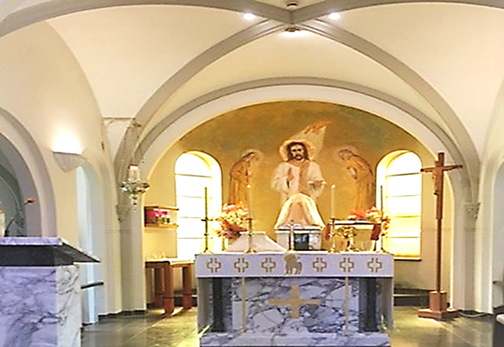
PO Box 105 (21C Frederick Street) Oatley 2223
Rev. Paul Hilder – Parish Priest
Mrs. Nancy Miletic – Operations Manager (Tues & Wed)
‘Phone 9580 1864, Email: oatleycc@bigpond.net.au
Parish website: www.stjosephschurch.com.au
St. Joseph’s Catholic Primary School, Oatley
Mrs Kylie Brakel – Principal. ‘Phone 9580 6588

St. Joseph’s Mass Times
Saturday Vigil: 5.00 pm Sunday: 8 am and 10 am
Weekday Masses: at 8 am on Monday, Tuesday, Wednesday, Friday & Saturday
Thursday: Mass at 12 md
Public Holidays: 9 am only
Confessions are available before the 5 pm Vigil Mass (4 pm to 4.45 pm)

WELCOME BACK
St Joseph’s Church is open from 7 am to 6 pm daily, and the usual Mass timetable as above apply. We look forward to seeing everyone at Mass.

31st July 2022 – Eighteenth Sunday in Ordinary Time

Masses for the Deceased: Elias Francis, Laurence Battikha, Salvatore Trimboli, Sister Christine Imbruglia rsj, Linda Ellen Hilder, Cardinal Edward Bede Clancy, Fr. George Connolly, Fr, Christopher Sheehy, Father William Evans, anniversaries.

SELF SATISFACTION: There is a story of man who was told that he could have as much property as he could go round in one day. He set off at a tremendous pace making as wide a circle as possible and ran so hard towards the end that he had a heart-attack and died. So that all he actually got was a six-foot hole in the village cemetery. That story is reminiscent of the vivid little parable given to us by Our Lord in today’s Gospel. It is story of a man who set his mind on amassing wealth so that he could spend his days in having a good time, completely forgetful of his ultimate destiny and the purpose of his experience.
St. Ignatius of Loyola begins his book of the Spiritual Exercises with a very logical statement. Having said that we are created to praise, reverence, and serve God, he goes on to say that all the things that were created were to help us to gain salvation and that therefore we should make use of them in so far as they help us to save our souls. However, we should refrain from their use in so far as they hinder us from doing so.
Unfortunately, many people use the things of God’s creation for their own personal self-satisfaction without any reference to God. This is one of the great dangers in our civilisation. Our scientific and technological age has produced so many things to please the eye and comfort the body and entice the mind that they so easily block out the vision of God in the world. Our Lord said that man cannot live by bread alone. The worship of material goods, for themselves alone, is stultifying and so easily, instead of creating self-satisfaction, does the very opposite.
The answer to all this must be to create the vision of faith by prayer. There is nothing wrong in money-making to have reasonable comforts for oneself and family. It becomes wrong when money is the be-all and end-all of one’s existence.

Church Open: Our church is open each day for weekday Masses and Sunday Masses at 5pm (Saturday Vigil), 8am and 10am, Sundays. We look forward to seeing everyone at Mass.

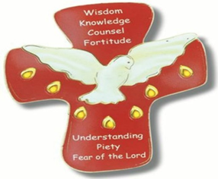
CONFIRMATION: This Weekend at the Vigil Mass on Saturday evening and the 10 am Mass on Sunday, we will be formally sending the Confirmandi off with our prayers and blessing to be Confirmed by the Archbishop and his Auxiliaries at St Mary’s Cathedral on the 7th August. May the Lord be with them always on their journey of faith and strengthen them with the gifts of the Spirit for the years that lie ahead.
The parish will formally welcome them back on the 14th August when they will receive their Confirmation Certificates.
​
FIRST HOLY COMMUNION 2022 (Year 3 and above) Term Three: Applications now open – Close 7th of August. (See details on the parish website www.stjosephschurch.com.au in the tab Sacramental Dates 2022). Additionally, click on the application form attached for further details and enrolment. Application and enrolment.

RECONCILIATION 2022 (Year 2 and above) Term Four: Applications open at the end of Term 3. (See details on the parish website www.stjosephschurch.com.au)
CHILDREN’S LITURGY during the Sunday 10am Mass:
We are looking forward to welcoming our young parishioners back to Children’s Liturgy during the 10am Sunday Mass. Children will have the opportunity to celebrate and reflect on the Sunday Gospel reading in an age-appropriate way. Children are led through prayer, songs, craft, and readings that are adapted to their level of understanding. We are fortunate to have some volunteers to lead this work and we would be grateful for any interested parishioners to contact oatleycc@bigpond.net.au if they would be keen to assist in this important ministry.

The Parish now has the facility to stream our Sunday Masses: You can access this on YouTube by following this link: bit.ly/stjoatley OR
CURRENT PLANNED GIVING: Planned Giving Envelopes for the new financial year are now available in the foyer of the Church, please take your set of envelopes.

New Contributors: If you wish to become part of our regularly giving programme at St Joseph’s Parish Oatley, please fill in the planned giving form, which can be accessed by clicking on the following Application Form. You can choose between making a regular monthly credit card contribution. Whereby, once set up, your contribution is processed each month. This is a good way to "set and forget" you’re giving to support the running of our parish. Alternatively, you may wish to contribute via the envelope system. If you would like to give by credit card on a monthly basis, OR give via the envelope system please download and complete the attached Application Form
Alternatively, please pick up a form in the Church foyer or email the office for a copy. Upon completion of your details email it to oatleycc@bigpond.net.au otherwise place the form in the second collection.
Your contribution to the 2nd collection goes towards the running and upkeep of our parish, and 30% of what you donate is eligible for a tax deduction.
TAX RECEIPTS for 2021-2022 will be available in the middle of August. Please email oatleycc@bigpond.net.au if you wish to receive a tax receipt. Your receipts will be emailed to you. Alternatively, call the office on 9580-1864 for your tax receipt. Once again, we would like to thank all who have kindly contributed to our parish at St Joseph’s Oatley.
Thank you for contributing to St. Joseph’s Parish. Fr. Paul

