St. Joseph’s Catholic Church Oatley
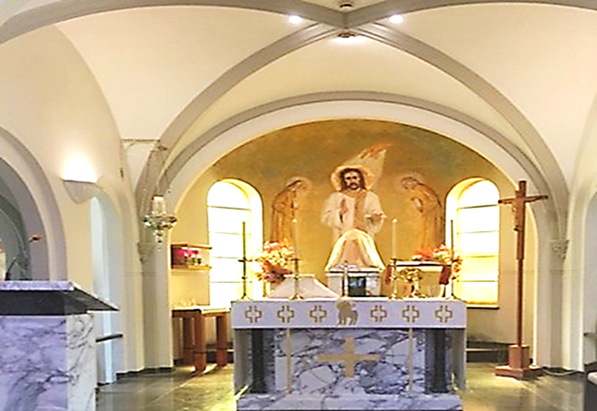
PO Box 105 (21C Frederick Street) Oatley 2223
Rev. Paul Hilder – Parish Priest
Mrs. Nancy Miletic – Operations Manager (Tues & Wed)
‘Phone 9580 1864, Email: oatleycc@bigpond.net.au
Parish website: www.stjosephschurch.com.au
St. Joseph’s Catholic Primary School, Oatley
Mrs Kylie Brakel – Principal. ‘Phone 9580 6588

St. Joseph’s Mass Times
Saturday Vigil: 5.00 pm Sunday: 8 am and 10 am
Weekday Masses: at 8 am on Monday, Tuesday, Wednesday, Friday & Saturday
Thursday: Mass at 12 md
Public Holidays: 9 am only
Confessions are available before the 5 pm Vigil Mass (4 pm to 4.45 pm)

WELCOME BACK
St Joseph’s Church is open from 7 am to 6 pm daily, and the usual Mass timetable as above apply. We look forward to seeing everyone at Mass.

7th August 2022 – Nineteenth Sunday in Ordinary Time

Masses for the Deceased: Masses for the Deceased: Carmel Rooke, Mildred Pettit, recently deceased; Mary Catherine Williamson, Michael Allen, Lina Kolozsi, Lorna Davey, Joan Moloney, Kathleen Rohl, anniversaries.

THE TREASURE: Dame Edith Sitwell, in her book “The Eccentrics”, tells of a miser who descended in the vault of his house to gloat over his treasures and found himself walled in by the falling of a trapdoor. Search was made everywhere for him without success. At last, it was given up and the house sold. The new owner wished to make some alterations in the cellar and a workman found the miser surrounded by glittering gold and jewels. Beside him lay a candlestick empty because the candle had been eaten. In the pangs of hunger, the miser had gnawed the flesh from both his arm.
Our Lord once said: Beware of covetousness, for a man’s life does not consist in the abundance of his possessions. True Christians have a kind of double vision. They see the world as others do, its beauty, its ugliness, its sorrows and joys, its horrors, and its attractions. It is seen also as a place of advancement and happiness, but we do not see any of these as finalities. We see God at work in us and the world. We know that Christ has experienced them. We do not view the world through rose-coloured spectacles; rather we see it all in its harsh reality but at the same time knowing that there is a divine providence at work.
Our Lord says in today’s Gospel: Where your treasure is there will your heart be also. The miser had his heart set on his treasure, and it brought him death. The Christian’s treasure is the love of God which brings life. Another name for the treasure is the Kingdom. Our Lord tells us: Fear not, little flock, for it is your Father’s good pleasure to give you a kingdom. To posses this kingdom was must not let our possessions so get a hold on us that they make the entrance to the kingdom impossible. St. Augustine said, “Love and do what you like”. Love is the answer.

The Parish now has the facility to stream our Sunday Masses: You can access this on YouTube by following this link: bit.ly/stjoatley OR

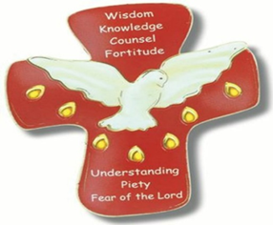
CONFIRMATION: This Sunday, the boys and girls we sent forth last Sunday will be Confirmed by the Archbishop and his Auxiliaries at St Mary’s Cathedral at a Special Mass commencing at 3.30pm. The Mass will be livestreamed, and the link is:
https://youtu.be/3qlEaKZMBFk
May the Lord be with them always on their journey of faith and strengthen them with the gifts of the Spirit for the years that lie ahead.

The parish will formally welcome them back on the 14th of August when they will receive their Confirmation Certificates.
​
FIRST HOLY COMMUNION 2022 (Year 3 and above) Term Three: Applications now open – Close 7th of August. (See details on the parish website www.stjosephschurch.com.au in the tab Sacramental Dates 2022). Additionally, click on the application form attached for further details and enrolment. Application and enrolment.

RECONCILIATION 2022 (Year 2 and above) Term Four: Applications open at the end of Term 3. (See details on the parish website www.stjosephschurch.com.au)

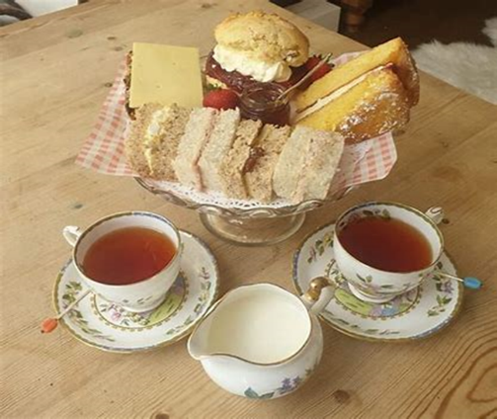

PARISH MORNING TEA: Our next parish Morning Tea will be on the 17th of August, at 10.30 am in the Marion Hall (go through the Church). Please save the date. Everyone is WELCOME. Please join us. Fr. Paul

CHILDREN’S LITURGY during the Sunday 10am Mass:
We are looking forward to welcoming our young parishioners back to Children’s Liturgy during the 10am Sunday Mass.

Parish Renewal Conference 2022-International biblical scholar Dr Scott Hahn to Speak Live, online at the Parish Renewal Conference:
Dr Hahn, Archbishop Anthony Fisher OP and a stellar array of speakers will address Sydney’s faithful at the upcoming Parish Renewal Conference. Join us as Dr Hahn, a convert from evangelical Christianity, explores the perennial call to be Evangelising Catholics in the midst of A Culture in Need of the Gospel.
Register at www.gomakedisciples.org.au/prc22 St Mary’s Cathedral Precinct Friday 19 August, 6 – 9 pm and Saturday 20 August, 9 am– 5:15 pm, $25 per person for parishioners in the Archdiocese of Sydney
Parishes are invited to promote the conference on social media using this tile.

Parish Renewal Conference 2022: You are warmly invited to join with Sydney’s faithful for a day-and-half, as we gather in-person for the inaugural Parish Renewal Conference. This will be an opportunity to hear stellar speakers, pray together and share ideas on renewing our parishes.
Register today at gomakedisciples.org.au so that together we can strengthen parish life! Specifically tailored for our clergy, lay leaders and parishioners to be renewed in the Church's mission of evangelisation, join us to strengthen your practical efforts through spiritual, intellectual, pastoral and human formation.
St Mary’s Cathedral Precinct Friday 19 August, 6 – 9 pm and Saturday 20 August, 9 am – 5:15 pm, $25 per person for parishioners in the Archdiocese of Sydney. Tickets are heavily subsidised by the Sydney Centre for Evangelisation.

TAX RECEIPTS for parishioners’ part of the envelope or credit card giving program for 2021-2022 are available. Please email oatleycc@bigpond.net.au if you wish to receive a tax receipt. Thank you to all who have kindly contributed to our parish at St Joseph’s Oatley. Fr. Paul

